**Dynamic Models Of Student**

* **Take Exam**

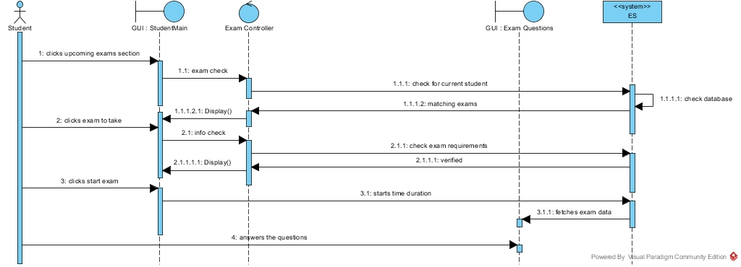

* **Answer Question**

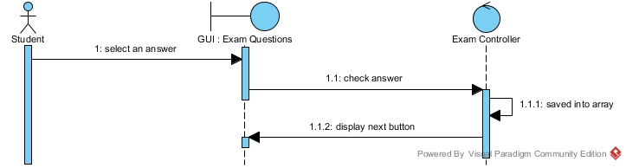

* **Submit Exam**

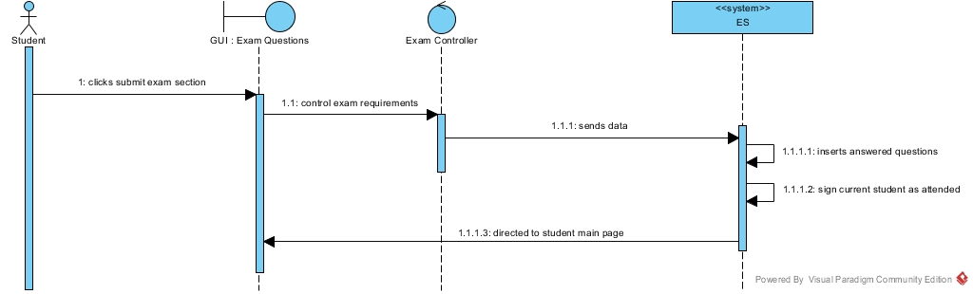

* **List Exam Results**

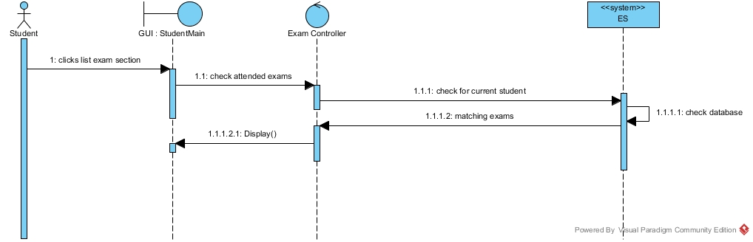

* **View Answers**

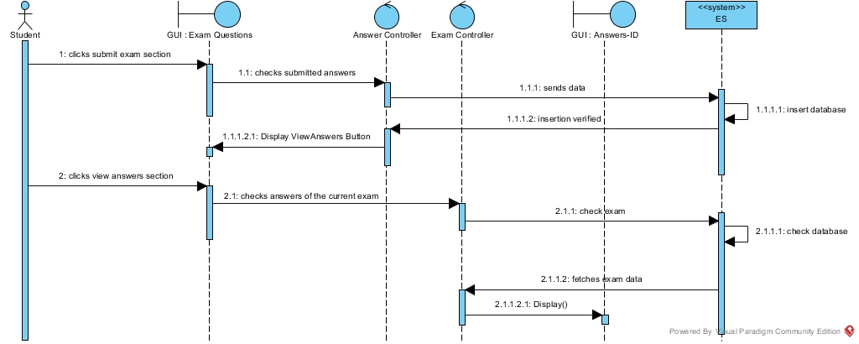

* **Authentication**

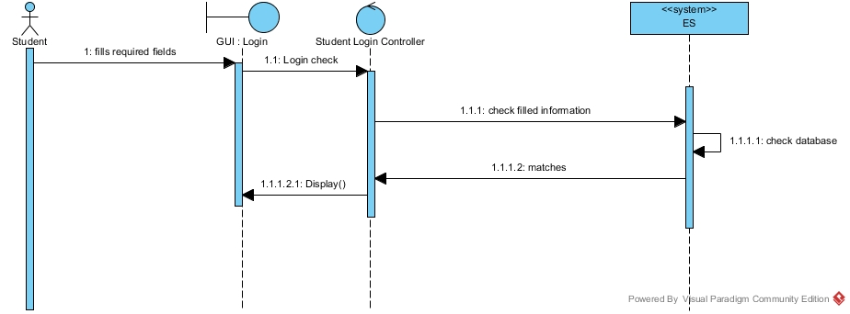

**Activity Diagram Of Student**

